**32.2)**

**## Use Hbase shell for performing the following operations**

**## Create the table customer with two column families**

**## Personal details and order details as column families. Create a unique number as row key (ssn/Aadhar no.,etc) Insert at least 10 records to each column Insert following values for personal details column family Name, age, city, state**

**## Insert following values for order details column family**

**##Order no., order quantity, and order amount**

**## Use put command to insert the values for each record. Use get command, to retrieve all the records of single customer.**

**Creating table customer with two column families personal and order.**

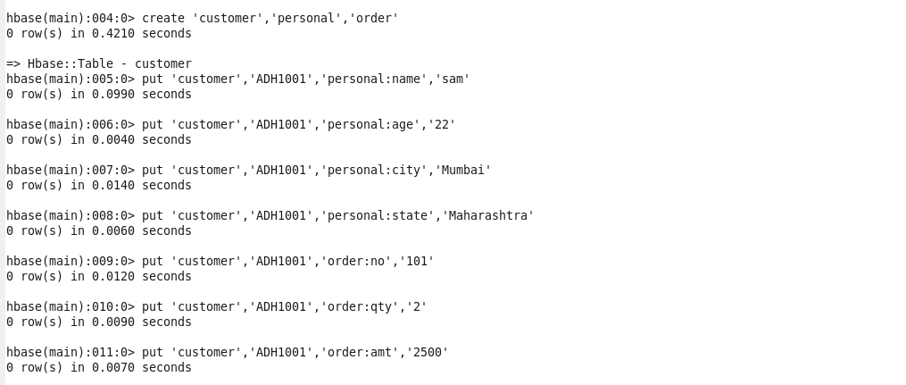

**Put command used to insert details of record.**

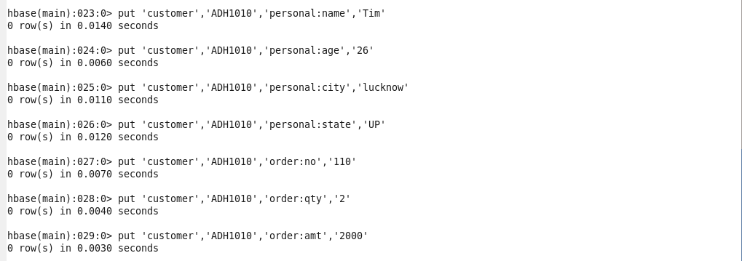

**Get command used to retrieve details of record with row key ADH1008.**

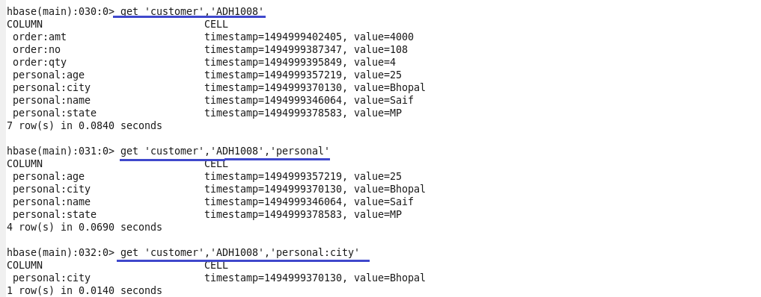

**Scan command used to display details of all 10 records.**

